­­­

**FUNDAMENTAL OF PROGRAMMING**

***LAB MANUAL 9***

**LAB TASKS**

**NAME :** Daniyal Ahmed

**CLASS :** ME-15

**SECTION :** B

**CMS ID :** 457165

**DATE:09/12/2023**

**TASK 1**

#include <bits/stdc++.h>

using namespace std;

int main()

{

int arr[3][3],left_diag=0,right_diag=0;

cout<<"Enter the values in matrix : \n ";

for(int i=0 ; i<3 ; ++i){

for(int j=0 ; j<3 ; ++j){

cin>>arr[i][j];

}

}

for(int k=0 ; k<3 ; ++k){

cout<<"|";

for(int l=0 ; l<3 ; ++l){

cout<<arr[k][l]<<" ";

}

cout<<"|"<<endl;

}

for(int i=0;i<3;++i){

for(int j=0;j<3;++j){

if(i==j){

left_diag+=arr[i][j];

}

}

}

int j=2;

for(int i=0;i<3;++i){

right_diag+=arr[j][i];

--j;

}

cout<<"The sum of principal diagonal is "<<left_diag<<".\n"<<"The sum of secondary diagonal is "<<right_diag<<"."<<endl;

return 0;

}

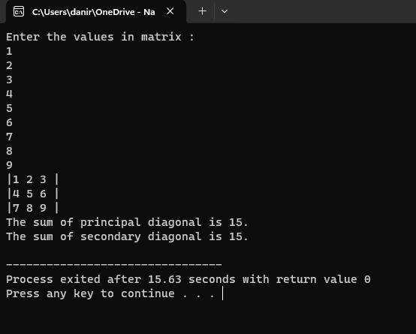

**TASK 2**

#include <bits/stdc++.h>

using namespace std;

int main()

{

int a[3][3],b[3][3],sum[3][3];

cout<<"Enter the values in the first matrix : \n";

for(int i=0;i<3;++i){

for(int j=0;j<3;++j){

cin>>a[i][j];

}

}

cout<<"The first matrix is : \n";

for(int m=0;m<3;++m){

cout<<"|";

for(int n=0;n<3;++n){

cout<<a[m][n]<<" ";

}

cout<<"|";

cout<<endl;

}

cout<<"Enter the values in the second matrix : \n";

for(int x=0;x<3;++x){

for(int y=0;y<3;++y){

cin>>b[x][y];

}

}

cout<<"The second matrix is : \n";

for(int c=0;c<3;++c){

cout<<"|";

for(int d=0;d<3;++d){

cout<<b[c][d]<<" ";

}

cout<<"|";

cout<<endl;

}

cout<<"The sum of these two matrices is : \n";

for(int k=0;k<3;++k){

cout<<"|";

for(int l=0;l<3;++l){

sum[k][l] = a[k][l] + b[k][l];

cout<<sum[k][l]<<" ";

}

cout<<"|";

cout<<endl;

}

return 0;

}

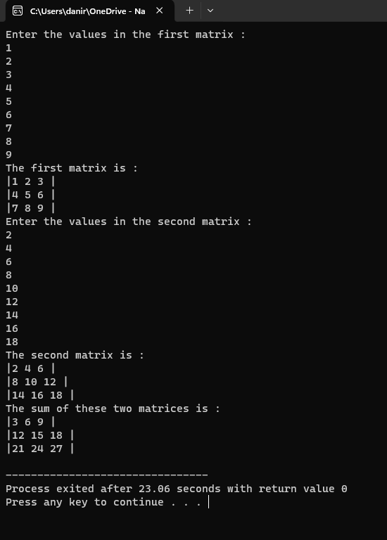

**TASK 3**

#include <iostream>

using namespace std;

int transpose(int arr[3][3]){

int temp=0;

for(int i=0; i<3; i++){

for(int j=i+1; j<3; j++){

temp=arr[i][j];

arr[i][j]=arr[j][i];

arr[j][i]=temp;

}

}

}

int main(){

int arr[3][3];

cout<<"Enter the values in matrix : "<<endl;

for(int i=0; i<3; i++){

for(int j=0; j<3; j++){

cin>>arr[i][j];

}

}

cout<<"The values in the matrix are: "<<endl;

for(int k=0; k<3; k++){

cout<<"| ";

for(int l=0; l<3; l++){

cout<<arr[k][l]<<" ";

}

cout<<"|"<<endl;

}

cout<<"The transpose of the matrix is: "<<endl;

transpose(arr);

for(int m=0; m<3; m++){

cout<<"| ";

for(int n=0; n<3; n++){

cout<<arr[m][n]<<" ";

}

cout<<"|"<<endl;

}

}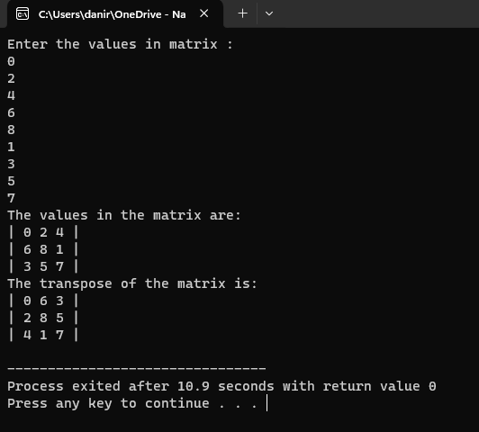

**TASK 4**

#include <bits/stdc++.h>

using namespace std;

int multiply(int a[3][3], int b[3][3], int product[3][3]){

for(int i=0; i<3; i++){

for(int j=0; j<3; j++){

for(int k=0; k<3; k++){

product[i][j]+=a[i][k]*b[k][j];

}

}

}

}

int main(){

int a[3][3], b[3][3], product[3][3]={{0},{0}};

cout<<"Enter the values in matrix A : "<<endl;

for(int i=0; i<3; i++){

for(int j=0; j<3; j++){

cin>>a[i][j];

}

}

cout<<"Enter the values in the matrix B : "<<endl;

for(int k=0; k<3; k++){

for(int l=0; l<3; l++){

cin>>b[k][l];

}

}

cout<<"The values in the matrix A and B are : "<<endl;

for(int m=0; m<3; m++){

cout<<"| ";

for(int n=0; n<3; n++){

cout<<a[m][n]<<" ";

}

cout<<"| | ";

for(int x=0; x<3; x++){

cout<<b[m][x]<<" ";

}

cout<<"|"<<endl;

}

multiply(a, b, product);

cout<<"The product of the two matrices A and B is: "<<endl;

for(int y=0; y<3; y++){

cout<<"| ";

for(int z=0; z<3;z++){

cout<<product[y][z]<<" ";

}

cout<<"|"<<endl;

}

return 0;

}

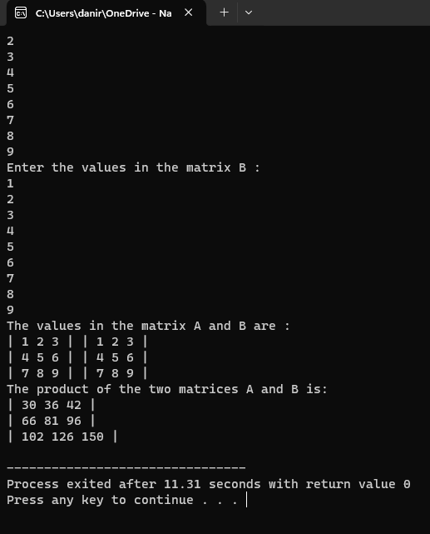

**TASK 5**

#include <bits/stdc++.h>

using namespace std;

int table(int num, int multiplier=1){

if(multiplier==11){

return 0;

}

cout<<num<<"*"<<multiplier<<"="<<multiplier*num<<endl;

return table(num, multiplier+1);

}

int main(){

int num, product;

cout<<"Enter the number whose table you want to print : "<<endl;

cin>>num;

cout<<"The table of "<<num<<" is: "<<endl;

table(num);

return 0;

}

